**Group by clause:**

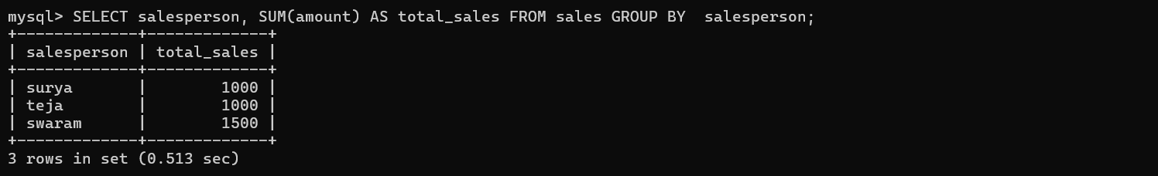

**HAVING Clause:**

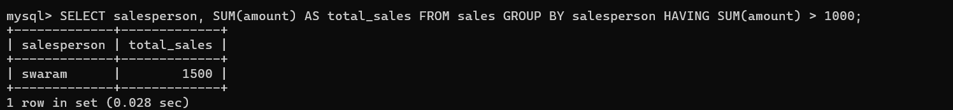

**ORDER BY Clause:**

